Redistricting changes little for Oceanside and Island Park
By Alex Costello

February 9, 2012

Under the proposed redistricting maps for New York State, some Oceanside residents may find themselves with a new district in the Assembly.
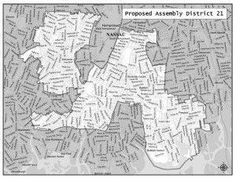
The shape of the 21st Assembly District is changing drastically, but Oceanside's representation within the district would remain the same.

The maps, released late last month, are based on data from the 2010 census. The New York State Legislative Task Force on Demographic Research and Reapportionment created the maps. While some districts are drastically redrawn, others remain very much the same. The biggest change is in the western-most part of Nassau County, which will be receiving an entirely new district.

Districts for both the Assembly and the Senate have been redrawn. Senate District 9, which is represented by Majority Leader Dean Skelos (R-Rockville Centre) is nearly unchanged. All residents in Oceanside and Island Park will still have Skelos as their representative.

The real changes are in the Assembly districts. Currently, all of Island Park and most of Oceanside are represented by Assemblyman Harvey Weisenberg (D-Long Beach) in District 20. A few residents in the more northern parts of Oceanside fall into District 14, which is represented by Assemblyman Brian Curran (R-Lynbrook).

Under the new maps, residents north of Atlantic Avenue and east of Long Beach Road (in the vicinity of Woods and Rockaway Avenues) would no long be in District 14, but would now be in District 21. Although the shape would change, Curran would still represent the district if reelected.

AD-020, AD-014

